International Trophée Mille « Service & Sommelier »
2024 – 13th edition

REGISTRATION FORM

This document must be completed, signed and returned, with all requested documents, by email to : contact@trophee-mille.fr
A e-mail will be send to confirm the registration and quality of documents.
If you don’t receive this e-mail, 5 days after your sending, please contact us by phone.

REQUESTED DOCUMENTS:

For 29 January 2024, 00:00:

- 250-word text (in Word format) written by the team on the theme "Are restaurant service and sommellerie complementary professions?

- Descriptive sheet
- Measurements file, completed by each candidate who don’t know their size in the Bragard Brand. One file per person.
- Image rights completed by candidates
- Image rights completed by accompanying teacher
- Valid school leaving certificate for both candidates
- Your school's logo in high definition
- A photo of the candidates taking part, with recommendations to be found on page 7
- Your chosen tablecloth:
We ask you to use the layouts suggested in this registration pack, by filling in this document directly on the computer and not by hand in order to avoid any legibility errors. All documents must be sent in Word (not pdf, excel or png) and photos in JPEG or PNG (no scans or pdf), to facilitate the layout of your file for the day of the competition.

DESCRIPTIVE SHEET

SCHOOL

Name:

Adress:

Phone:

Email:

Web site:

The school's social networks:

PRINCIPAL or SUPERVISOR
Last Name
First Name
Phone
Cellphone
Mail

Signature of school director:

CARERS

Team coach
Last name
First name
Adress
City
Country
Cellphone
E-Mail

CANDIDATES TEAM

 | SERVICE & SOMMELIER
 | Candidate Service | Candidate Sommelier
Last name
Firts name
Adress
City
Country
Age and date of birth
Cellphone
E-Mail
Social networks Facebook and Instagram (for identification on our social networks)
Not mandatory
Size of vest (Complete the attached form if you don’t know your size in Bragard Brand).

SERVICE & SOMMELIER TEST

The competition tests will take place in two parts: a service part and a sommelier part. Each one is composed of 4 different tests and a final test is common to the two candidates.
Service tests:
- Cutting
- Tasting of cheeses from the Grand Est region
- Table art
- Buckling test

Sommelier tests:
- Presentation of champagnes
- Written questionnaire
- White wine decanting
- Order taking

Test common to both candidates:
- Carré des producteurs

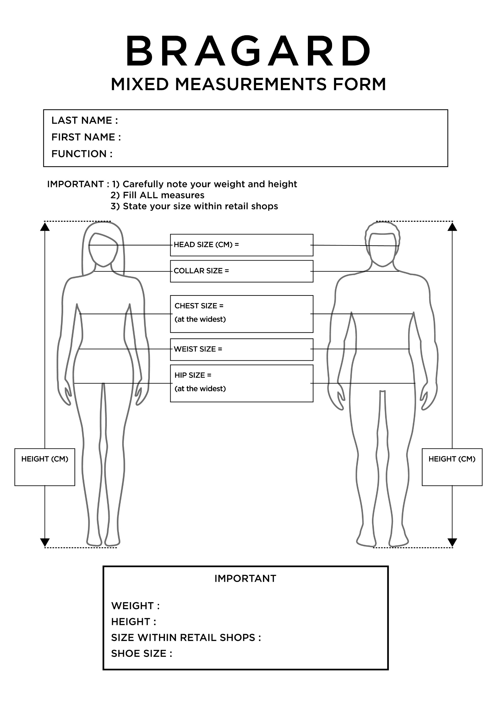

IMAGE RIGHT - ADULT

Object: Permission to take and use pictures and videos of you to communicate and promote the contest and our gastronomic heritage.

Dear Sir, Dear Madame,

Under the Trophée MILLE, international challenge of promotion of gastronomic heritage of the Grand Est region, photos and videos will be taken to enable the Trophée MILLE association, the Grand Est region, countries and institutions that have returned their act of commitment and contest participants to communicate and promote to the public, the regional heritage through different media and/or during regional, national or international events.

The Trophée MILLE association, medias, Grand Est region and institutions would like to have your permission to take pictures and videos of you.

The pictures and/or videos may be communicated to other persons, as mentioned above. It will be forbidden to either sell or use the pictures and/or videos for any other utilization than the following ones: to communicate, promote and value the gastronomic heritage and our contest.

In accordance with the law, the free access to photographical data and to video data concerning yourself is guaranteed. You will be able at any time to verify the utilization that is made with them and to have the right of withdrawal of these pictures and/or videos if there is any other utilization than: to communicate and promote the gastronomic heritage and our event.

In consequence, could you complete the form bellow, giving us the permission to make and use pictures and videos of you such as mentioned above?

We thank you in advance for your collaboration.

Madam, Mister (Last name/First name):
Position:
School:

Authorizes the Trophée Mille association, the Grand Est region, countries and institutions to:
- Take pictures and make videos of me;
-Stock and use these pictures;
-Copy and broadcast these pictures and videos during campaigns of communication and promotion of the Trophée MILLE

In ……………………………………………………………., on the ………………………………………………………

Signature: ………………………………………………………

IMAGE RIGHT - MINOR

Object: Permission to take and use pictures and videos of your child to communicate and promote the contest and our gastronomic heritage.

Dear Sir, Dear Madame,

Under the Trophée MILLE, international challenge of promotion of gastronomic heritage of the Grand Est region, photos and videos will be taken to enable the Trophée MILLE association, the Grand Est region, countries and institutions that have returned their act of commitment and contest participants to communicate and promote to the public, the regional heritage through different media and/or during regional, national or international events.

The Trophée MILLE association, medias, Grand Est region and institutions would like to have your permission to take pictures and videos of your child.

The pictures and/or videos may be communicated to other persons, as mentioned above. It will be forbidden to either sell or use the pictures and/or videos for any other utilization than the following ones: to communicate, promote and value the gastronomic heritage and our contest.

In accordance with the law, the free access to photographical data and to video data concerning your child is guaranteed. You will be able at any time to verify the utilization that is made with them and to have the right of withdrawal of these pictures and/or videos if there is any other utilization than: to communicate and promote the gastronomic heritage and our event.

In consequence, could you complete the form bellow, giving us the permission to make and use pictures and videos of your child such as mentioned above?

We thank you in advance for your collaboration.

Mister (Father or Tutor):
Madam (Mother or Tutor):
Legal representative of the student (Last name/ First name):

Authorizes the Trophée Mille association, the Grand Est region, countries and institutions to:
- Take pictures and make videos of this child
- Stock and use these pictures and videos
- Copy and broadcast these pictures and videos during campaigns of communication and promotion of the Trophée MILLE

(Father or Tutor) (Mother or Tutor)
(Signature) (Signature)

In ……………………………………………. In …………………………………………………
On the ……………………………………. On the …………………………………………...

GROUP’S PHOTO

In order to communicate about your candidates, a photo of candidates’ group is necessary, by following the next exemple:

Recommendations:

- Dressed in professional attire, without hat or apron
- Photo in color and not in B&W
- Picture in landscape format
- The photo should be taken on a white background (or plain)
- Each candidate must be sideways, back to each other, arms crossed, looking at the objective
- The male candidate must be on the right and the female candidate on the left
- For the positioning of the arms, the candidates will have to cross their arms below their chest.
- Photo frame: cut the photo at the hips

