International Trophée Mille "Cooking-Pastry »
2024 - 13th edition

APPLICATION FORM

Please complete the application form and return it with all the required documents,
to the following address: contact@trophee-mille.fr. An e-mail confirming receipt of your complete application will be sent to you as confirmation of your enrolment.

DOCUMENTS TO BE ATTACHED TO THE APPLICATION:

For 29 January, 00:00:
- Description form
- Measurement form, completed by candidates and accompanying persons who do not know their Bragard jacket or waistcoat size (one form per person)
- Image rights completed by candidates
- Image rights completed by the accompanying teacher
- Valid school leaving certificate for the 2 candidates
- Your school's logo in high definition
- A photo of the candidates taking part, with recommendations to be found on page 7
- Description of the savoury recipe with a photo of the savoury dish on a white plate
- Description of the sweet recipe with a photo of the sweet dish on a white plate
- Desired quantities of the required products :
  - Duck breast :
  - Saffron honey :
  - 72% blended chocolate :
  - Ratafia Solera 90-16 :

We ask you to use the layouts suggested in this registration pack, by filling in this document directly on the computer and not by hand to avoid any legibility errors. All documents must be sent in Word (not pdf, excel or png) and photos in JPEG or PNG (no scans or pdf), to facilitate the layout of your file for the day of the competition.

DESCRIPTION FORM

DESCRIPTION FORM

Name:

Address:

Phone:

Email:

Website:

The school's social networks:

Head of Teaching or Teaching Activity
Last name
First name
Landline telephone
Mobile phone
Email

Signature of school director:

SUPPORTER

ACCOMPAGNANT
Last name
First name
Address
Postal code
City
Mobile phone
Email
Jacket size (if you don't know your Bragard size, please fill in the size form below).

CANDIDATE TEAM

 | COOKING
 | Candidat 1 | Candidat 2
Last name
First name
Address
Postal code
City
Date of birth
Mobile phone
Email
Facebook and Instagram social networks (for identification on our social networks)
Not required
Jacket size (if you don't know your Bragard size, please fill in the size form below).
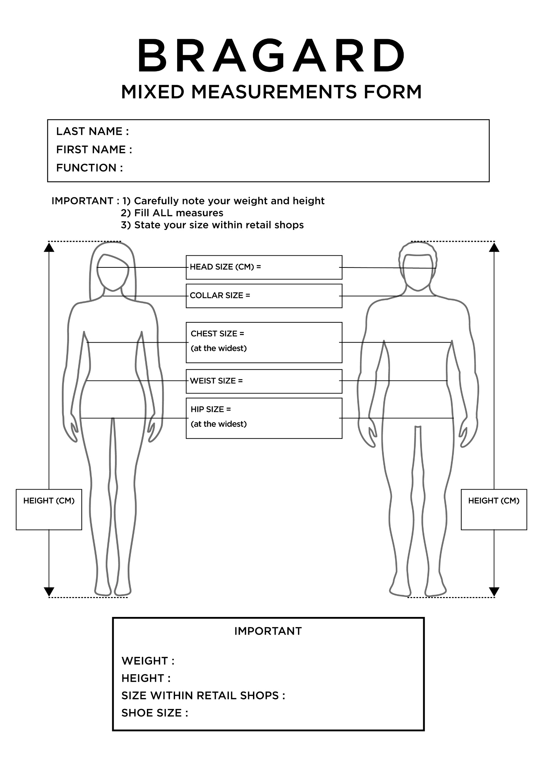
IMAGE RIGHT - MINOR

Object: Permission to take and use pictures and videos of your child to communicate and promote the contest and our gastronomic heritage.

Dear Sir, Dear Madame,

Under the Trophée MILLE, international challenge of promotion of gastronomic heritage of the Grand Est region, photos and videos will be taken to enable the Trophée MILLE association, the Grand Est region, countries and institutions that have returned their act of commitment and contest participants to communicate and promote to the public, the regional heritage through different media and/or during regional, national or international events.

The Trophée MILLE association, medias, Grand Est region and institutions would like to have your permission to take pictures and videos of your child.

The pictures and/or videos may be communicated to other persons, as mentioned above. It will be forbidden to either sell or use the pictures and/or videos for any other utilization than the following ones: to communicate, promote and value the gastronomic heritage and our contest.

In accordance with the law, the free access to photographical data and to video data concerning your child is guaranteed. You will be able at any time to verify the utilization that is made with them and to have the right of withdrawal of these pictures and/or videos if there is any other utilization than: to communicate and promote the gastronomic heritage and our event.

In consequence, could you complete the form bellow, giving us the permission to make and use pictures and videos of your child such as mentioned above?

We thank you in advance for your collaboration.

Mister (Father or Tutor):
Madam (Mother or Tutor):
Legal representative of the student (Last name/ First name):

Authorizes the Trophée Mille association, the Grand Est region, countries and institutions to:
- Take pictures and make videos of this child
- Stock and use these pictures and videos
- Copy and broadcast these pictures and videos during campaigns of communication and promotion of the Trophée MILLE

(Father or Tutor) (Mother or Tutor)
(Signature) (Signature)

In ……………………………………………. In …………………………………………………
On the ……………………………………. On the …………………………………………...

IMAGE RIGHT - ADULT

Object: Permission to take and use pictures and videos of you to communicate and promote the contest and our gastronomic heritage.

Dear Sir, Dear Madame,

Under the Trophée MILLE, international challenge of promotion of gastronomic heritage of the Grand Est region, photos and videos will be taken to enable the Trophée MILLE association, the Grand Est region, countries and institutions that have returned their act of commitment and contest participants to communicate and promote to the public, the regional heritage through different media and/or during regional, national or international events.

The Trophée MILLE association, medias, Grand Est region and institutions would like to have your permission to take pictures and videos of you.

The pictures and/or videos may be communicated to other persons, as mentioned above. It will be forbidden to either sell or use the pictures and/or videos for any other utilization than the following ones: to communicate, promote and value the gastronomic heritage and our contest.

In accordance with the law, the free access to photographical data and to video data concerning yourself is guaranteed. You will be able at any time to verify the utilization that is made with them and to have the right of withdrawal of these pictures and/or videos if there is any other utilization than: to communicate and promote the gastronomic heritage and our event.

In consequence, could you complete the form bellow, giving us the permission to make and use pictures and videos of you such as mentioned above?

We thank you in advance for your collaboration.

Madam, Mister (Last name/First name):
Position:
School:

Authorizes the Trophée Mille association, the Grand Est region, countries and institutions to:
- Take pictures and make videos of me;
-Stock and use these pictures;
-Copy and broadcast these pictures and videos during campaigns of communication and promotion of the Trophée MILLE

In ……………………………………………………………., on the ………………………………………………………

Signature: ………………………………………………………

GROUP’S PHOTO

In order to communicate about your candidates, a photo of candidates’ group is necessary, by following the next exemple :

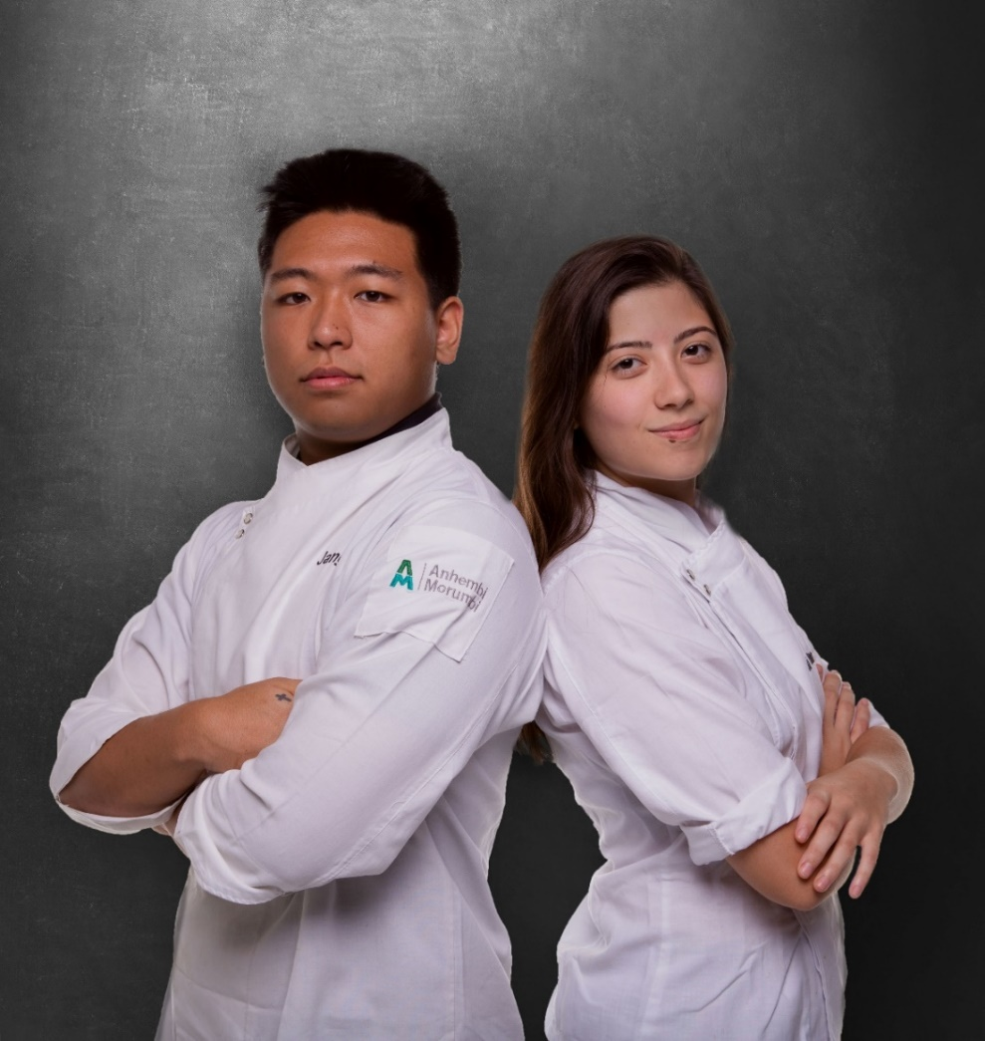

Recommendations :

- Dressed in professional attire, without hat or apron
- Photo in color and not in B&W
- Picture in landscape format
- The photo should be taken on a white background (or plain)
- Each candidate must be sideways, back to each other, arms crossed, looking at the objective
- The male candidate must be on the left and the female candidate on the right
- For the positioning of the arms, the candidates will have to cross their arms below their chest.
- Photo frame: cut the photo at the hips

RECIPE SHEET – SALTY DISH

Please send us your recipe sheets in editable Word format by 29 January 2024, so that we can standardise all the candidates' files for the day of the competition.

Recipe title - 24 words maximum:

Ingredient for 4 people:
Please give the complete, uniform list in the form of a list and not a table. Do not divide the list according to the stages in the kitchen..

- Xxx
- Xxx
- Xxx

Recipe description - 400 words maximum, including presentation:

Presentation :
Please specify how you would like your recipe to be dressed, to accompany the photo of your dish.
RECIPE SHEET – SWEET DISH

Please send us your recipe sheets in editable Word format by 29 January 2024, so that we can standardise all the candidates' files for the day of the competition.

Recipe title - 24 words maximum:

Ingredient for 4 people:
Please give the complete, uniform list in the form of a list and not a table. Do not divide the list according to the stages in the kitchen..

- Xxx
- Xxx
- Xxx

Recipe description - 400 words maximum, including presentation:

Presentation:
Please specify how you would like your recipe to be dressed, to accompany the photo of your dish.

